Contact us:
St Georges Road, Millom, Cumbria LA18 4LE, Tel: 01229 772840 email: admin@parkview-nur.cumbria.sch.uk
Parkview Nursery School
Information Leaflet

Welcome to Parkview Nursery School
Welcome to Parkview Nursery School in Millom.
We are very proud of the school which provides the young children of Millom and the surrounding villages with high quality early years’ education in an exciting and stimulating environment.
A friendly and dedicated staff team care for and support the children.
I hope you will find all the information you need here but if not please contact us at school using the details on the front of the leaflet.
If you would like to book a time to come and visit us prior to applying for a place with us, please do not hesitate to email or give us a call to arrange.
Rhiannon Hughes
Head teacher

Parkview Nursery School – ‘Inspiring young hearts, bodies and minds.’
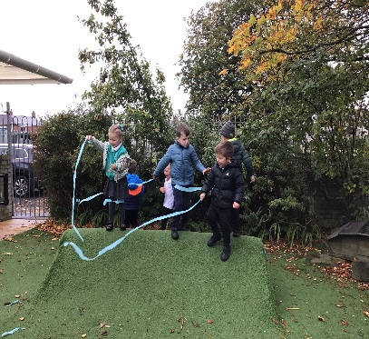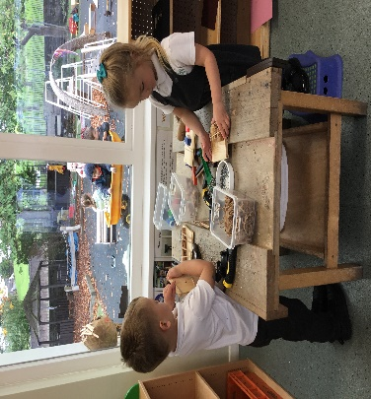

Our Vision:

We have a clear vision of what we want to achieve at Parkview Nursery School:

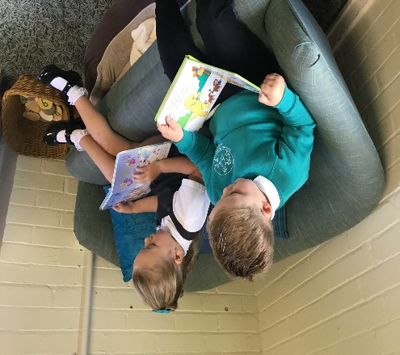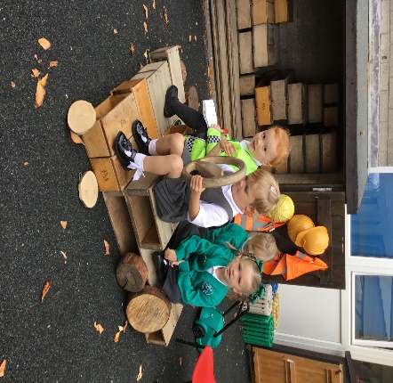

Our Aims are:

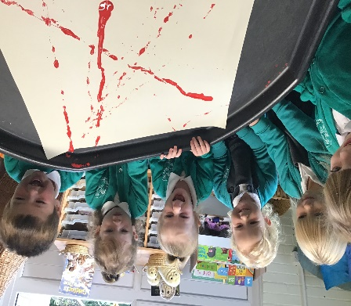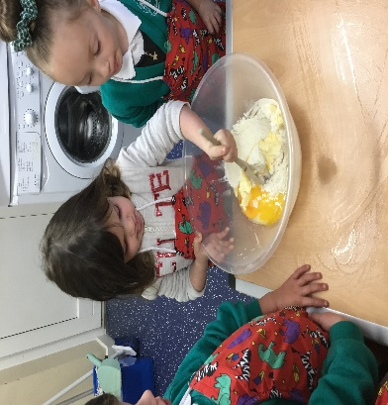

Our Values are:

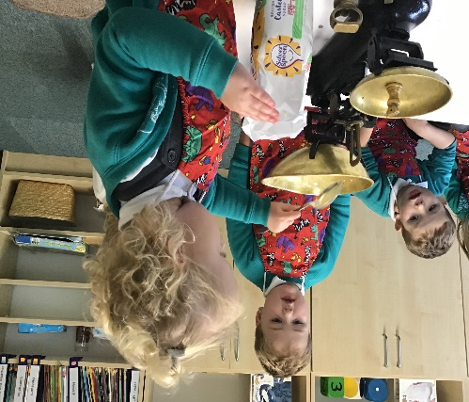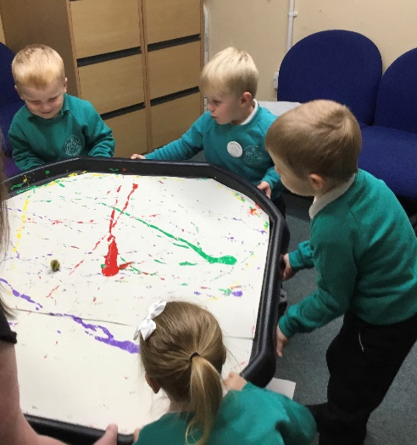

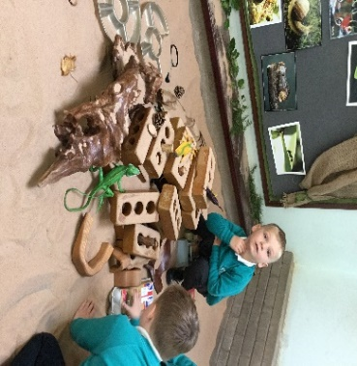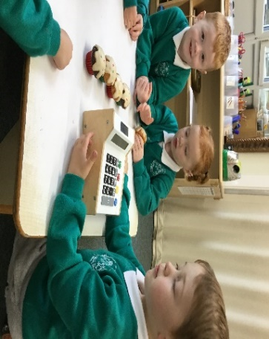

Working Together
Parents are the most important people in their children's lives and when your child comes to Nursery we build on the foundations which you have laid and will continue to develop at home. The partnership and relationship we build with parents is essential for the child's happiness and development. We plan our curriculum around the children’s interests and are keen to hear what they are interested in at home.
Home Visits
We visit all children in their homes before they start - children remember this visit throughout their time at Nursery and often say 'you came to my house....'. As staff we thoroughly enjoy seeing the children in their own home.
How do parents know what their child is doing in Nursery?
On the way home or at home some children are very chatty about what they have been doing but others will make little comment.
Your child's key worker will always be happy to talk with you - they will always try to tell you if something important has happened and will be happy to arrange a time to talk to you if you have any concerns.
We also arrange more formal meetings for you to talk to your child's keyworker about your child's progress.
Learning Stories
We keep a Learning Story for each child, this contains observations, photos, examples of their work etc. and shows how they are learning and developing at school. This will come home with your child at the end of the year and is available throughout the year for you to share with your child and their family. We are always happy to have contributions from home to put in these books and sheets are available from Nursery.
Trips
We welcome parents to join us on trips as parent helpers to the library, local shops, the woods etc. as well as our main trip at the end of the year. This helps us ensure safety as well as giving children an interested adult to talk to on the trip.
Home Learning Bags
All children have their own book bag and can choose a book every day to take home to share with their family. Your child may also sometimes bring home a rucksack with an activity for you to do at home. This may be a 'Funky Finger' bag to develop the fine motor skills needed for writing, a 'Maths' bag with a simple game to improve your child's mathematical development or an ‘Active’ bag including resources to develop gross motor skills.
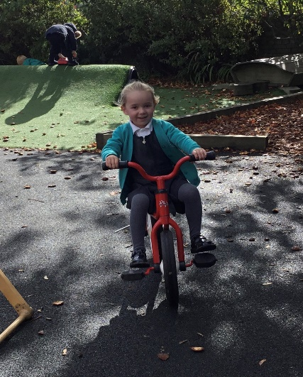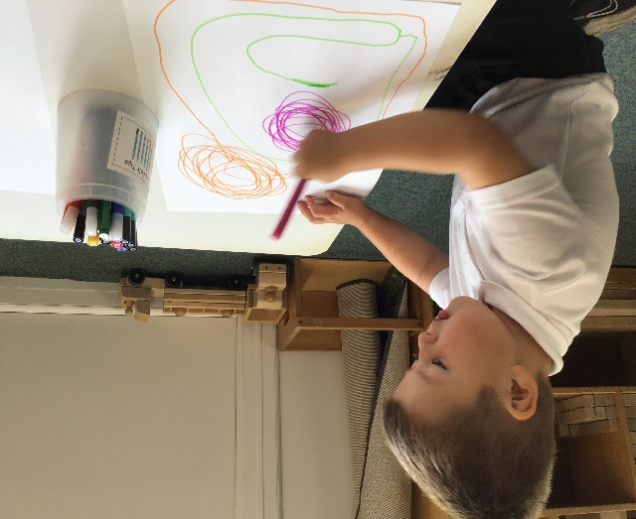

As a Local Authority Maintained Nursery School we offer:
- 3-year-old funded places (15 hours a week)

- 3-year-old funded places for working parents (up to 30 hours a week)

- Flexible sessions which can be used for full days or half days to fit in with parent’s needs (parents may pay for additional sessions if wished)

- Experienced Nursery teachers and teaching assistants

- A carefully planned learning environment aimed to stimulate joy and curiosity in our youngest learners

- Hot lunches
We work closely with Stepping Stones Nursery next door who can provide wrap around and holiday provision for children attending Parkview Nursery.
